**Climate: Part I Factors Effecting a Regions Climate**

**Name:________________________________________________________ Date:_______________________**

**Part I: Factors which effect a regions climate**

What is **Climate?_________________________________________________________________________________**

**________________________________________________________________________________________**

1. ___________________________- Determines ______________ ______________________ based off amount of incoming insolation

As distance from Equator ________, the temperature generally ________ .

*The further N or S you are of the equator the _________ your seasonal temperature change.

1. 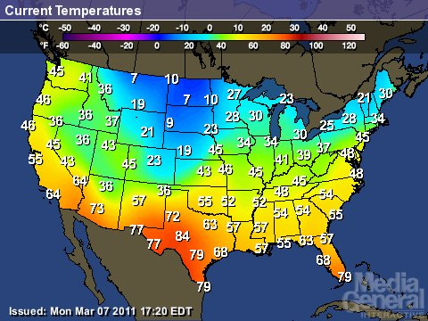_________________________________________________________   
   Water has a _________________________________(pg 1 ESRT), which means it takes a long time to heat up (_________________________________________) and a long time to cool down (________________________________)
2. _________________________________

As altitude increases, temperature _________________________.

Is it possible to have snow/ice at the equator? _____________

1. 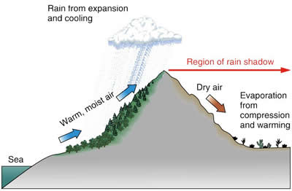______________________ ___________________________: a combination of prevailing wind patterns with the presence of mountain ranges
   1. Windward side: ________________________________

_____________________________________________

* 1. Leeward side: __________________________________

______________________________________________

1. _____________ ______________:The surface temperature of an ocean current affects the air which lies above it (Temp &Humidity)

**Using pg. 4** of the ESRT: How does the California current effect temperatures on the US West coast?

How does the North Atlantic Current effect temperatures to Western Europe and the U.K?

1. ___________________________ _________________- (pg. 14 of ESRT)

_______ ____________ ____________: 90 and 30 N/S latitudes. These are the worlds _____________

________ ___________ ____________: 0 and 60 N/S latitudes. These are _________ zones.

1. ________________ _____________________: which effect the typical storm tracks of a region

**Storm systems** generally move from the west to the east and more specifically to the North East due to the ___________________________________________________

**Hurricane Tracks:** start in East Atlantic and move ___________ toward Caribbean and U.S. by the ______________ _________________

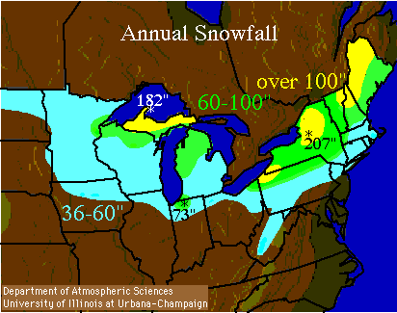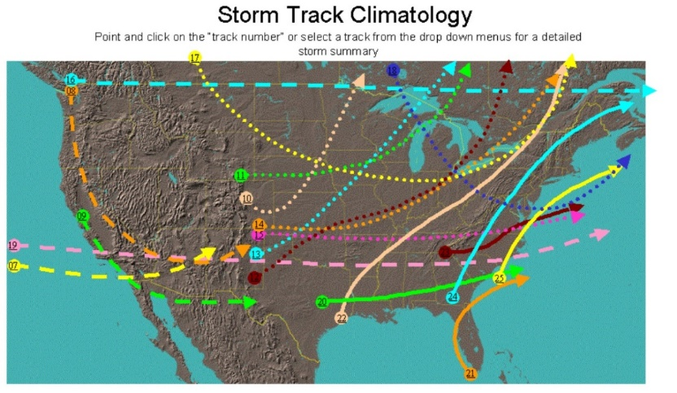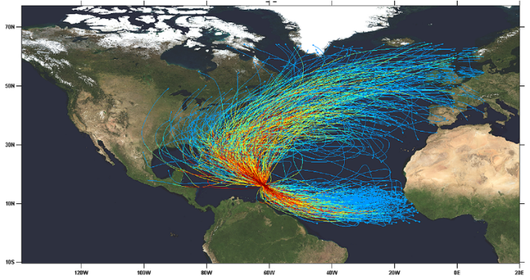At ___________________ they turn and track ____________ by the prevailing southwesterlies

**Lake Effect Snow -**Around _____________________________ Areas

-A ___________________ mass of air (cP or cA) moves over a _______________ of water (great lakes) and causes _______________________

8.) Cloud Cover-

*The hottest regions on earth are actually experienced in the dry desert regions around 30 N/S, NOT the equator due to high cloud coverage in wet areas!*

1. 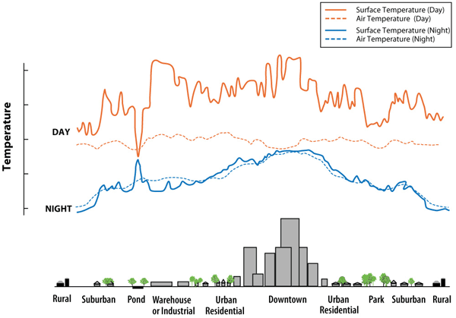Vegetation- _________________________and ____________________ ultimately lead to localized climate change.

Vegetation uses incoming solar energy for ____________________ and ___________________, which will keep localized temperatures *__________________*

1. By cutting down trees and increasing grassland/asphalt surfaces, ____________ energy is used to heat the surfaces, thus *_____________________* temperature